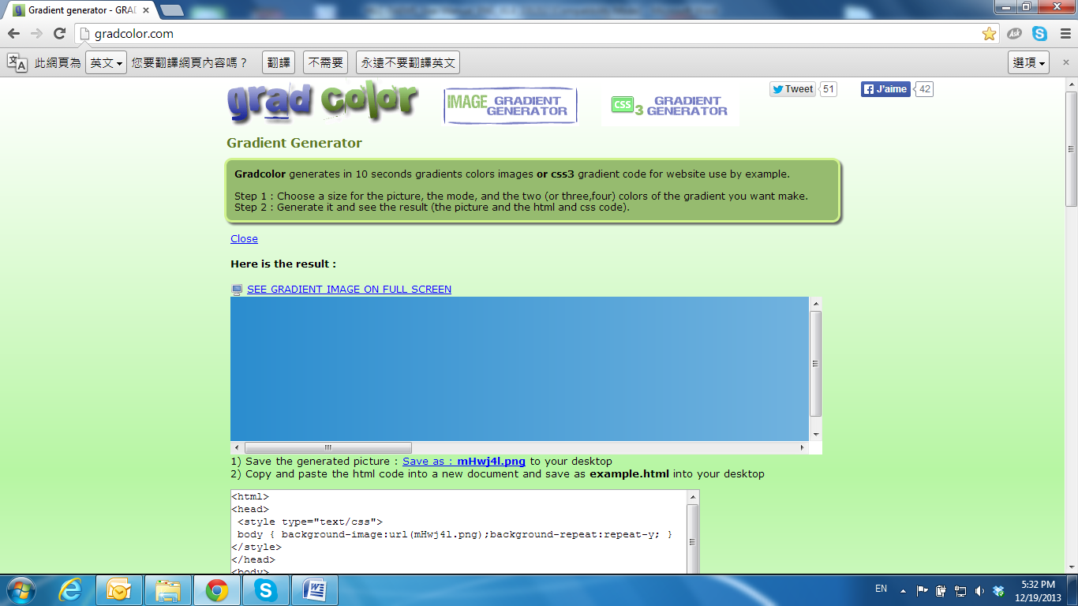

I / O Configuration

**1. I/O Connection**

a. Connect the **G (GND)** & **DO** wires to the external relay (buzzer) device.

b. Connect the **G (GND)** & **DI** wires to the external trigger device.

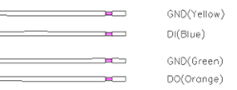

When no event occurs, the DO output is 5V (DO and GND are disconnected). When the camera detects events it will trigger and external alarm, DO output is 0V (DO and GND are connected).

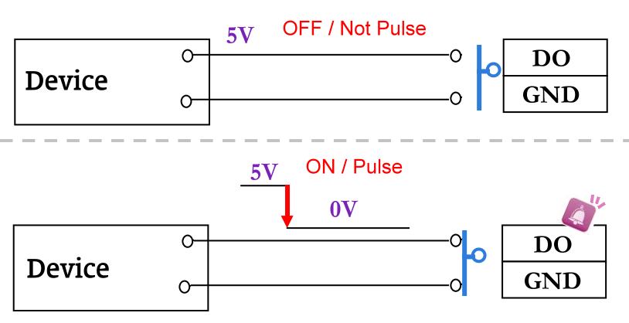

If you select **N.O** on **Input sensor setting**, when the switch contacts are opened, the camera input alarm will be triggered and will execute the action user has set, for example, send a snapshot to E-mail address.

If you select **N.C** in **Input sensor setting**, when the switch contacts are closed, the camera input alarm will be triggered and will execute the action user has set, for example, send a snapshot to E-mail address.

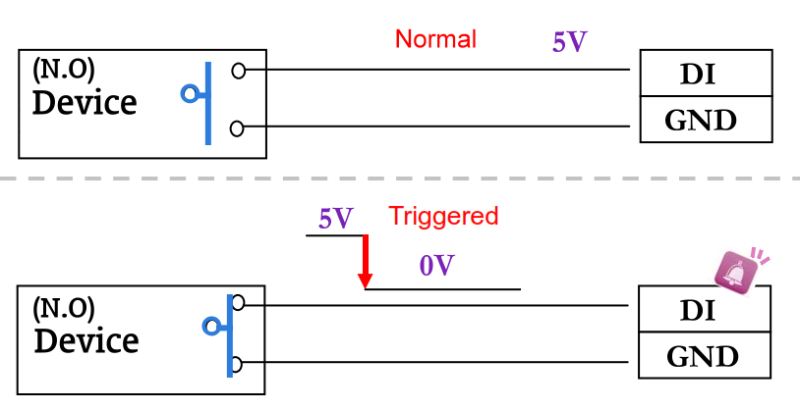

c. I/O definitions

• **GND (Ground):** Initial state is LOW

• **DO (Digital Output):** DC 5V

• **DI (Digital Input):** Max. 50mA, DC 5V

**2. I/O Setup**

a. Click **I/O Setting** from the system setup page via IE, and check **Out1** to enable I/O signal.

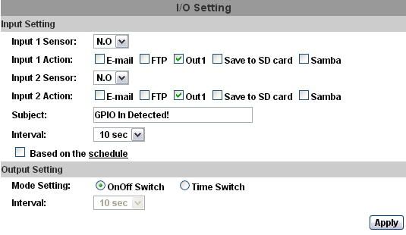

b. Output Test

After the external input and output hardware is installed, you can use the **Relay Out** bottom on the live video page to test if DO / Relay Out works.

* + - * 1. On Off Switch mode:

Clicking **ON** will trigger the external output device for 10 seconds. For example, your alarm buzzer will continuously ring for 10 seconds. After 10 seconds the buzzer stops ringing, or you can manually break off the output signal by clicking **OFF**.

relayplateado

* + - * 1. Time Switch mode:

Click **Pulse**, the camera will trigger the external output device for several seconds; the duration length is according to the **interval** setting in Output Setting.

pulseplateado